THE BAGHPAT COOPERATIVE SUGAR MILLS LIMITED;BAGHPAT

Telephone: (0121) 2221029 Fax: (0121)2221835

(0121)2221835 Email: baghpat.sugar@yahoo.co.in
bptsugar@gmail.com

COMPETITIVE e-bidding

Cane Transportation from Out Center for Year, 2023-24

e-bid REFERENCE : CANE/C.T.A/2023-24/1015

LAST DATE AND TIME FOR : 11-08-2023 UPTO 11.00 AM

SUBMISSION OF E-Bids

DATE AND TIME OF OPENING : 11-08-2023 AT 3.00 PM

OF ON LINE TECHNICAL e-Bids

PLACE OF OPENING OF e-Bids : The Baghpat Cooperative Sugar Mills Ltd., Baghpat

ADDRESS FOR COMMUNICATION : General Manager,
The Baghpat Cooperative Sugar Mills Limited,
BAGHPAT

e-Bid E.M.D : E.M.D for 0 to 0.50 lac Qtl 10,000/- (Rs. Ten Thousand only), 0.51 lac qtl to 1.00 Lac Quintal Cane Supply Rs. 20,000/- (Rs. Twenty thousand only) for each Cane Purchase Center& E.M.D for Above 1.00 Lac Quintal Cane Supply Rs. 30,000/- (Rs. Thirty thousand only) for each Cane Purchase Center.

This Document Contains -- 35 Pages

It will be the responsibility of the e-Bidders to check U.P. Government e-Procurement website http://etender.up.nic.in for any amendment through corrigendum in the e-tender document. In case of any amendment, e-Bidders will have to incorporate the amendments in their e-Bids accordingly.

e-tender Document Processing /Cost : 500.00 + GST Rs.300Rs.300.00+GST 300.00300.00+GSTGST

INDEX

1 | e-Tender Notice | 03
2 | Invitation of e-Bids | 04-06
3 | Section I- Instruction to Bidders | 07-20
 | (A) The e-Bid Document | 07-08
 | (B) Preparation of e-Bids | 08-15
 | (C) e-Bid Opening and Evaluation of e-Bid | 15-19
 | (D) Award of Contract | 18-19
4 | Section II- Conditions of e-Tender / Contract (cc) | 20-23
5 | Section III- Technical e-Bid | 24
 | III(A) e Bid form | 25
 | III(B) Schedule of Requirements | 26
 | III(C) Technical Specifications | 27
 | III (E) Performance Statement | 29
 | III (F) Capability Statement | 30
 | Check List | 31-32
 | Section IV- Financial e-Bid | 33
 | IV(A) e- Bid Form | 34
 | IV (B) Price Schedule/BOQ | 35

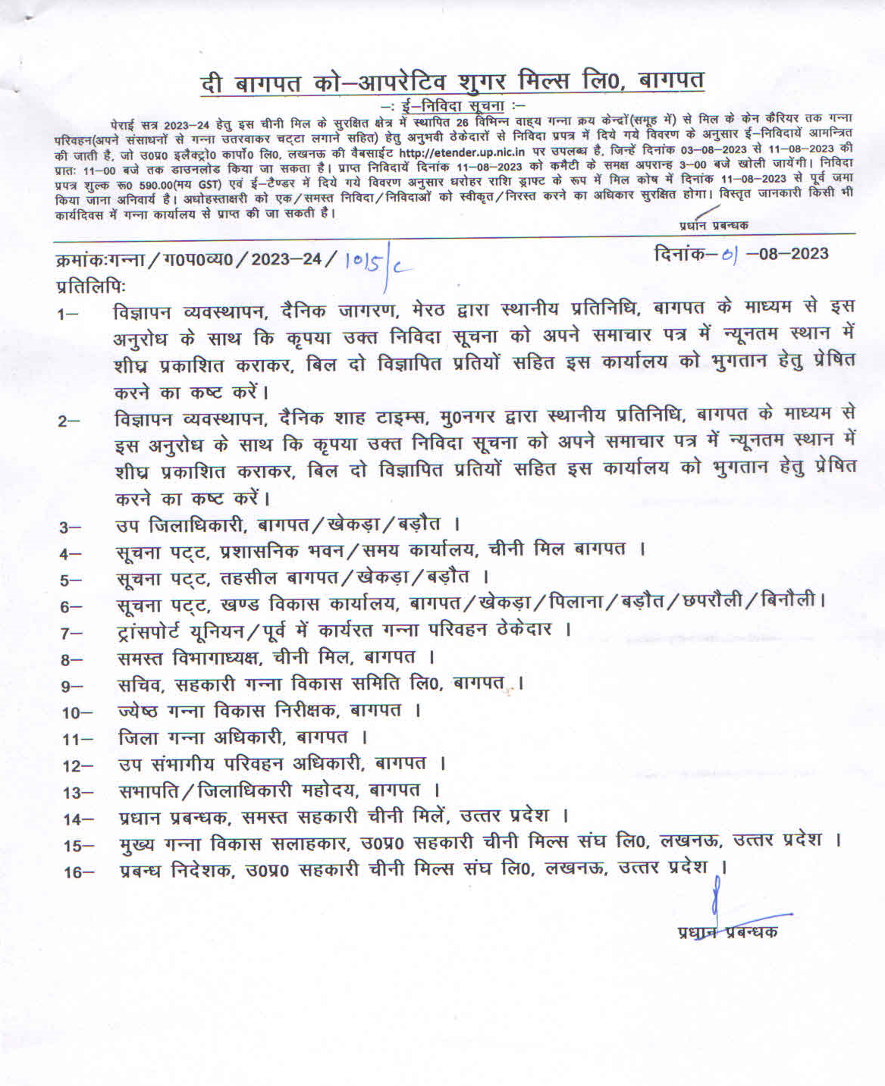

INVITATION FOR e-BidS

Online e-bids are invited for Cane Transportation Work from original manufacturers to our cooperative sugar factories located in Uttar Pradesh.

1. Bidders are advised to study the tender Document carefully. Submission of e-Bid against this tender shall be deemed to have been done after careful study and examination of the procedures, terms and conditions of the tender Document with full understanding of its implications.

2. The e-Bid prepared in accordance with the procedures enumerated in ITB Clause 15 of Section-I should be submitted through e-Procurement website http://etender.up.nic.in.

3. The tender document is available at e-Procurement website http://etender.up.nic.in from 03-08-2023 at 11.30 AM. Interested bidders may view, download the e-Bid document, seek clarification and submit their e-Bid online up to the date and time mentioned in the table below:

(a) | Date of publication of e-tender notice & availability of Tender Document | Tender Notice has been published over e-Procurement website http://etender.up.nic.in  tender Document will be available from 03-08-2023 at 11.30 AM at e-Procurement web site http://etender.up.nic.in
(b) | Availability of tender document on website | 03-08-2023 at 11.30 AM at e-Procurement web site http://etender.up.nic.in
(c) | Clarification start date & time | 03-08-2023 at 11.30 AM
(d) | Clarification end date & time | 11-08-2023 upto 11.00 AM
(e) | e-Bid submission start date & time (Submission of e-tender fee, EMD and other supporting documents in PDF/XLS format) | 03-08-2023 at 11.30 AM
(f) | e-Bid submission end date & Time | 11-08-2023 upto 11.00 AM
(g) | Online technical e-Bid opening date & time | 11-08-2023at 3.00 PM
(h) | Online financial e-Bid opening date & time (Only of technically qualified bidders) | 11-08-2023 at 3.00 PM

(i) | Venue of opening of technical & financial e-Bids | The Baghpat Cooperative Sugar Mills Limited,  Baghpat
(j) | Contact officer | Name: MrRajdeep Singh, Chief Cane Officer  Mobile No.7880888924.  Mr. Rakesh Kumar Sharma Sr. Dy. Manager EDP Mob.7906890988
(k) | Cost of e-Bid document | Rs 500.00 (Rupees Five hundred Only)  (Non-refundable) + GST
(l) | e-Bid E.M.D | E.M.D for 0 to 0.50 lac Qtl 10,000/- (Rs. Ten Thousand only), 0.51 lac qtl to 1.00 Lac Quintal Cane Supply Rs. 20,000/- (Rs. Twenty thousand only) for each Cane Purchase Center & E.M.D for Above 1.00 Lac Quintal Cane Supply Rs. 30,000/- (Rs. Thirty thousand only) for each Cane Purchase Center.

4. The bidders need to submit the proof/cost of e-Bid document/processing as stated in the above table in Cash in the Mill Society's office or through Demand Draft in favour of The Baghpat Cooperative Sugar Mills Ltd., Baghpat (herein after referred as BCSM/Mill Society) payable at Baghpat. The scanned copy of the Cash Deposit Receipt or Demand Draft or Banker’s Cheque must be enclosed along with the e-Bids but the original Demand Draft or Banker’s Cheque should reach the office of The Baghpat Cooperative Sugar Mills Ltd., Baghpat before opening of technical e-Bid.

5. All e-Bid must be accompanied by e-Bid Earnest Money Deposit (EMD) in the form of Demand Draft, drawn in favour of The Baghpat Cooperative Sugar Mills Ltd., Baghpat. The scanned copy of the e-Bid EMD must be submitted along with the e-Bid and the original should reach the Office of Baghpat Coop. Sugar Mill before opening of technical e-Bids. No Interest would be payable on e-Bid (Earnest Money) deposited with Sugar Mill.

6. The e-Bids will be electronically opened in the presence of bidder’s representatives, who choose to attend at the venue, date and time mentioned in the above table. An authority letter of bidders’/OEM representative will be required to be produced.

7. The General Manager reserves the right to cancel any or all the e-Bids/annul the e-Bid process without assigning any reason thereof. The decision of General Manager will be final and binding.

8. In the event of date specified for e-Bids opening being declared a holiday for Sugar Mills’s office then the due date for opening of e-Bids shall be the following working day at the appointed time and place.

All the required documents including Price Schedule/BOQ should be uploaded by the e-Bidder electronically in the PDF/XLS format. The required electronic documents for each document label of Technical (Fee details, Qualification details, e-Bid Form and Technical Specification details) schedules/packets can be clubbed together to make single different files for each label.

The companies/firms who are registered at e-Procurement portal for e-tendering with UP Electronics Corporation Ltd, 10 Ashok Marg, Lucknow-226002, would only be eligible for participating in this e-tender as well as in e-tendering system of U.P. Govt. departments. All companies/firms who have not registered themselves with UPLC Ltd ,Lucknow for e-tendering till date can get their registration done by depositing a filled in form issued by UPLC Ltd, Lucknow along with registration fee of Rs. 6000.00 (Rupees Six thousand only) for participating in this e-tender and other e-tenders of U.P.Govt. departments. The companies/firms, who are not having digital signature, can also get their digital signature on deposit of processing fees of Rs.1500.00 (Rupees One thousand five hundred only). The companies/firms may contact the officials on phone numbers (0522) 4130303 Extn 305 & 307, 09721451211, for their Registration/Digital Signature Certificate related queries. The registration fee may also be deposited through RTGS. The details of RTGS are as under:

SECTION I : INSTRUCTIONS TO BIDDERS (ITB)

(A) THE BID DOCUMENT

1-Cost of e-Bid

a) The bidder shall bear all costs associated with the preparation and submission of its e-Bid and The Baghpat Coop. Sugar Mills Ltd., Baghpat hereinafter referred to as “the Mill Society”, will in no case be responsible or liable for these costs, regardless of the conduct or outcome of the e-Bid process.

b) This tender document is available on the web site http://etender.up.nic.in to enable the bidders to view, download the e-Bid document and submit e-Bids online up to the last date and time mentioned in e-Tender notice/e-tender document against this e-Tender. The bidders shall have to pay e-Tender document fee of Rs 500.00 (Rupees Five hundred Only)+ GST in cash or through Demand Draft or Banker’s Cheque payable in favour of The Baghpat Cooperative Sugar Mills Ltd., Baghpat The scanned copy of the Cash Deposit Receipt or Demand Draft or Banker’s Cheque must be enclosed along with the e-Bid but the original Demand Draft or Banker’s Cheque should reach the Mill Society’s office before opening of the technical e-Bid. This e-e-tender document fee of Rs. 500.00+GST will be non-refundable.

2-Contents of e-Bid Document

2.1 The goods required to be supplied; e-Bid procedure and contract terms and conditions are prescribed in the e-Bid document. The e-Bid document includes:

Invitation for e-Bid

Section I : Instruction to bidders (ITB);

Section II : Conditions of E-tender/Contract (CC);

Section III : Technical e-Bid;

Section IV : Financial e-Bid;

2.2 The bidder is expected to examine all instructions, forms, terms and specifications in the e-Bid document. Failure to furnish all information required as per the e-Bid document or submission of e-Bid not responsive to the e-Bid document in every respect will be at the bidder’s risk and may result in rejection of the said e-Bid.

3-Clarification of e-Bid Document

A prospective bidder requiring any clarification of the e-Bid document may raise his/her point of clarification through Bid Management Window after successfully login to the e-Procurement website http://etender.up.nic.in. The bidder may seek clarification by posting query in the relevant window after clicking "Seek Clarification" option in the view e-tender details window for e-tender which can be selected through my tender option of e-Bid submission menu. The clarification will be replied back by the Mill Society through the e-Procurement website which can be read by the bidder through the "Clarification" option under Bid Submission menu. The Mill Society may also respond to clarifications raised by the prospective bidders on Mill Society's e-mail address baghpat.sugar@yahoo.co.in or bptsugar@gmail.com

4. Amendment of e-Bid Document

4.1 At any time prior to the deadline for submission of e-Bid, the Mill Society may, for any reason, whether at its own initiative or in response to a clarification requested by a prospective bidder, modify the e-Bid document by amendments. Such amendments shall be uploaded on the e-Procurement website http:// etender.up.nic.in through corrigendum and shall form an integral part of e-Bid document. The relevant clauses of the e-Bid document shall be treated as amended accordingly.

4.2 It shall be the sole responsibility of the prospective bidders to check the web site http://etender.up.nic.in from time to time for any amendment in the e-tender document. In case of failure to get the amendments, if any, the Mill Society shall not be responsible for it.

4.3 In order to allow prospective e-Bidders a reasonable time to take the amendment into account in preparing their e-Bids, the Mill Society, at his discretion, may extend the deadline for the submission of e-Bids. Such extensions shall be uploaded on the e-Procurement website http://etender.up.nic.in.

(B) PREPARATION OF e-Bid

5 Language of e-Bid

5.1 The e-Bid prepared by the bidder, as well as all correspondence and documents relating to the e-Bid exchanged by the bidder and the Mill Society shall be written either in English or Hindi language. The correspondence and documents in Hindi must be accompanied by embedded/separate Hindi font files. Only English numerals shall be used in the e-Bid.

6 Documents Constituting the e-Bid

6.1 The e-Bid prepared by the bidder shall comprise the following components:

(a) Technical e-Bid - Technical e-Bid will comprise of:

(i) Fee Details includes copies of e-tender document processing/Cost and e-Bid Earnest Money Deposit furnished in accordance with ITB Clause 12 in PDF format.

(ii) Qualification Details – includes copies of required documents as per ITB Clauses 10 and 11 in PDF format justifying that the bidder is qualified to perform the contract if his/her bid is accepted and that the bidder has financial, technical and production capability necessary to perform the contract and meets the criteria outlined in the Qualification Requirement and Technical Specification and fulfill all the conditions of the Contract and that the goods and ancillary services to be supplied by the bidder conform to the e-Bid document and Technical Specifications.

(iii) e-Bid Form – includes copy of filled in e-Bid Form as per Section-III(A) of e-tender document in PDF format justifying that the bidder is complying with all the conditions of the Contract and Technical Specifications of the e-Bid Document as no deviation will be acceptable to the Mill Society.

(iv) Technical Specification Details – includes copy of filled in Technical Specifications as per Section-III(C) of e-tender document in PDF format.

(b) Financial e-Bid – Financial e-Bid will comprise of :

(i) e-Bid Form – includes copy of filled in e-Bid Form as per Section-IV (A) of e-tender document in PDF format.

(ii) Price Schedule/BOQ includes Price Schedule/BOQ in XLS format to be filled in after downloading from the e-Procurement website for this e-tender.

7-e-Bid Form

7.1 The bidder shall complete the e-Bid Form and the appropriate Price Schedule/BOQ furnished in the e-Bid document, including the goods to be supplied, their quantities and prices in the format given in the e-Bid document.

8 e-Bid Price

8.1 The bidder shall quote separately in the downloaded spread sheet file for the Price of Cane Transportation Work

8.2 The work of Missionary to be done at Mill Site on labour rate basis.

(a) The Rate of Cane Transportation Workmust be on labour rate basis.

8.3 Prices quoted by the bidder shall be fixed during the bidder’s performance of the Contract and not subject to variation on any account subject to ITB Clause 25.1. A e-Bid submitted with an adjustable price quotation unless asked for shall be treated as non-responsive and rejected.

9 e-Bid Currencies

Prices shall be quoted in Indian Rupees only.

10 Documents Establishing bidder’s Qualification

10.1 Pursuant to ITB Clause 6, the bidder shall furnish, as part of its Technical e-Bid, documents establishing the bidder’s qualification to perform the Contract if its e-Bid is accepted. The documentary evidence should be submitted by the bidder electronically in the PDF format.

The documentary evidence of bidder’s qualification to perform the Contract if its e-Bid is accepted shall be as per Qualification Requirements specified in Section III (D) of e-tender document.

11 Documents Establishing Goods’ Conformity to e-Bid Documents

11.1 Pursuant to ITB Clause 6, the bidder shall furnish, as part of its e-Bid, documents establishing the conformity to the e-Bid documents of all goods and services which the bidder proposes to supply under the contract. The documentary evidence should be in the PDF file format.

12 e-Bid Earnest Money Deposit (EMD)

12.1 Pursuant to ITB Clause 6, the bidder shall furnish, as part of its e-Bid, an e-Bid E.M.D for 0 to 0.50 lac Qtl 10,000/- (Rs. Ten Thousand only), 0.51 lac qtl to 1.00 Lac Quintal Cane Supply Rs. 20,000/- (Rs. Twenty thousand only) for each Cane Purchase Center & E.M.D for Above 1.00 Lac Quintal Cane Supply Rs. 30,000/- (Rs. Thirty thousand only) for each Cane Purchase Center.for each Cane Purchase Center. in form of Demand Draft, in favour of The Baghpat Cooperative Sugar Mills Ltd., Baghpat The scanned copy of the e-Bid EMD must be submitted along with the e-Bid and the original should reach the Mill Society’s office at Baghpat before opening of technical e-Bid. No Interest on EMD will be paid.

12.2 The e-Bid E.M.D is required to protect the Mill Society against the risk of bidder’s conduct which would warrant the E.M.D’s forfeiture, pursuant to ITB Clause 12.7.

12.3 The e-Bid E.M.D shall be in Indian Rupees and shall be in the following forms only:

A Demand Draft payable in favour of The Baghpat Cooperative Sugar Mills Ltd., Baghpat payable at Baghpat

12.4 Any e-Bid not secured in accordance with ITB Clauses 12.1 and 12.3 above shall be treated as non-responsive and rejected by the Mill Society.

12.5 Unsuccessful bidder’s e-Bid E.M.D will be returned upon the written request through cheque or DD in original submitted at the time of E-bid as promptly as possible after the expiration of the period of e-Bid validity prescribed by the Mill Society, pursuant to ITB Clause 13.

12.6 The successful bidder’s e-Bid E.M.D will be converted in security and in addition to EMD equal amount of securitywill be deposited with Federation, pursuant to ITB Clause 28, and furnishing the performance security, pursuant to ITB Clause 29.

12.7 The e-Bid E.M.D may be forfeited:

(a) if a bidder (i) withdraws its e-Bid during the period of e-Bid validity specified by the bidder on the e-Bid Form; or (ii) does not accept the correction of errors pursuant to ITB Clause 22.2; or (iii) modifies its e-Bid price during the period of e-Bid validity specified by the bidder on the e-Bid form or

(b)In case of a successful bidder, if the bidder fails:

(i)to sign the Contract with the Mill Society in accordance with ITB Clause 28; or

(ii)To furnish performance security in accordance with ITB Clause 29.

13 Period of Validity of e-Bid

13.1 e-Bid shall remain valid up to 90 days and the Orders for the period up to which the crushing of season 2023-24 continues of the cooperative factories of federation or 30/06/2024 whichever is later after the date of e-Bid opening prescribed by the Mill Society, pursuant to ITB Clause 16. An e-Bid valid for a shorter period shall be rejected by the Mill Society as non-responsive.

13.2 In exceptional circumstances, the Mill Society may solicit the bidder’s consent to an extension of the period of e-Bid validity. The request and the response thereto shall be made in writing. A bidder may refuse the request without forfeiting its e-Bid security. A bidder granting the request will not be required nor permitted to modify its e-Bid.

14 Format and Signing of e-Bid

14.1 The bidder shall prepare one electronic copy each of the Technical e-Bid and Financial e-Bid separately.

14.2 The e-Bid document shall be digitally signed, at the time of uploading, by the bidder or a person or persons duly authorized to bind the bidder to the Contract. The letter authorization shall be indicated by a scanned copy of written power-of-attorney accompanying the e-Bid. All the pages/ documents of the e-Bid that are to be uploaded shall be digitally signed by the person authorized to sign the e-Bid.

15. Submission of e-Bid

The Bid Submission module of e-Procurement website http://etender.up.nic.in enables the bidders to submit the e-Bid online in response to this e-tender published by the Mill Society. Bid Submission can be done only from the Bid Submission start date and time till the Bid Submission end date and time given in the e-tender. Bidders should start the Bid Submission process well in advance so that they can submit their e-Bid in time. The bidders should submit their e-Bid considering the server time displayed in the e-Procurement website. This server time is the time by which the e-Bid submission activity will be allowed till the permissible time on the last/end date of submission indicated in the e-tender schedule. Once the e-Bid submission date and time is over, the bidders cannot submit their e-Bid. For delay in submission of e-Bid due to any reasons, the bidders shall only be held responsible.

The bidders have to follow the following instructions for submission of their e-Bid:

15.1 For participating in e-Bid through the e-tendering system, it is necessary for the bidders to be the registered users of the e-Procurement website http:// etender.up.nic.in. The bidders must obtain a User Login Id and Password by registering themselves with U.P. Electronics Federation Limited, Lucknow if they have not done so previously for registration. Refer to details given in Invitation for e-Bid Clause 10.

15.2 In addition to the normal registration, the bidder has to register with his/her Digital Signature Certificate (DSC) in the e-tendering system and subsequently he/she will be allowed to carry out his/her e-Bid submission activities. Registering the Digital Signature Certificate (DSC) is one time activity. Before proceeding to register his/her DSC, the bidder should first log on to the e-tendering system using the User Login option on the home page with the Login Id and Password with which he/ she has registered as per clause 15.1 above.

For successful registration of DSC on e-Procurement website http://etender. up.nic.in the bidder must ensure that he/she should possess Class-2/ Class-3 DSC issued by any certifying authorities approved by Controller of Certifying Authorities, Government of India, as the e-Procurement website http:// etender.up.nic.in is presently accepting DSCs issued by these authorities only. The bidder can obtain User Login Id and perform DSC registration exercise as described in clauses 15.1 and 15.2 above even before e-Bid submission date starts. The Mill Society shall not be held responsible if the bidder tries to submit his/her e-Bid at the last moment before end date of submission but could not submit due to DSC registration problem.

15.3 The bidder can search for active tenders through "Search Active tenders" link, select a tender in which he/she is interested in and then move it to ‘My Tenders’ folder using the options available in the e-Bid Submission menu. After selecting and viewing the tender, for which the bidder intends to e-Bid, from "My Tenders" folder, the bidder can place his/her e-Bid by clicking "Pay Offline" option available at the end of the view tender details form. Before this, the bidder should download the e-tender document and Price Schedule/Bill of Quantity (BOQ) and study them carefully. The bidder should keep all the documents ready as per the requirements of e-tender document in the PDF format except the Price Schedule/Bill of Quantity (BOQ) which should be in the XLS format (Excel sheet).

15.4 After clicking the ‘Pay Offline’ option, the bidder will be redirected to the Terms and Conditions page. The bidder should read the Terms & Conditions before proceeding to fill in the Tender Fee and EMD offline payment details. After entering and saving the Tender Fee and EMD details, the bidder should click "Encrypt & Upload" option given in the offline payment details form so that "Bid Document Preparation and Submission" window appears to upload the documents as per Technical (Fee details, Qualification details, e-Bid Form and Technical Specification details) and financial (e-Bid Form and Price Schedule/BOQ) schedules/packets given in the tender details. The details of the Demand Draft or any other accepted instrument which is to be physically sent in original before opening of technical e-Bid, should tally with the details available in the scanned copy and the data entered during e-Bid submission time otherwise the e-Bid submitted will not be accepted.

15.5 Next the bidder should upload the Technical e-Bid documents for Fee details (e-tender fee and EMD), Qualification details as per "ITB Clause 10 or 21", e-Bid Form as per "Section-III(A)" and Technical Specification details as per "Section-III(C):Technical Specifications" and Financial e-Bid documents as per "Section-IV(A):e-Bid Form" and "Section-IV(B):Price Schedule/BOQ" of e-tender document. Before uploading, the bidder has to select the relevant Digital Signature Certificate. He may be prompted to enter the Digital Signature Certificate password, if necessary. For uploading, the bidder should click "Browse" button against each document label in Technical and Financial schedules/packets and then upload the relevant PDF/XLS files already prepared and stored in the bidder's computer. The required documents for each document label of Technical (Fee details, Qualification details, e-Bid Form and Technical Specification details) and financial (e-Bid Form and Price Schedule/BOQ) schedules/packets can be clubbed together to make single different files for each label.

15.6 The bidder should click "Encrypt" next for successfully encrypting and uploading of required documents. During the above process, the e-Bid documents are digitally signed using the DSC of the bidder and then the documents are encrypted/locked electronically with the DSC’s of the bid openers to ensure that the e-Bid documents are protected, stored and opened by concerned bid openers only.

15.7 After successful submission of e-Bid document, a page giving the summary of e-Bid submission will be displayed confirming end of e-Bid submission process. The bidder can take a printout of the bid summary using the "Print" option available in the window as an acknowledgement for future reference.

15.8 Mill Society reserves the right to cancel any or all e-Bids without assigning any reason.

16-Deadline for Submission of e-Bid

16.1 e-Bid (Technical and Financial) must be submitted by the bidders at e-Procurement website http://etender.up.nic.in not later than time 11.00 AM and 11-08-2023 the date as mentioned on page 4 (as the server time displayed in the e-Procurement website).

16.2 The Mill Society may, at its discretion, extend this deadline for submission of e-Bid by amending the e-Bid document in accordance with ITB Clause 4, in which case all rights and obligations of the Mill Society and bidders previously subject to the deadline will thereafter be subject to the deadline as extended.

17 Late e-Bid

17.1 The server time indicated in the Bid Management window on the e-Procurement website http://etender.up.nic.in will be the time by which the e-Bid submission activity will be allowed till the permissible date and time scheduled in the e-tender. Once the e-Bid submission date and time is over, the bidder cannot submit his/her e-Bid. Bidder has to start the Bid Submission well in advance so that the submission process passes off smoothly. The bidder will only be held responsible if his/her e-Bid is not submitted in time due to any of his/her problems/faults, for whatsoever reason, during e-Bid submission process.

18 Withdrawal and Resubmission of e-Bid

18.1 At any point of time, a bidder can withdraw his/her e-Bid submitted online before the bid submission end date and time. For withdrawing, the bidder should first log in using his/ her Login Id and Password and subsequently by his/her Digital Signature Certificate on the e-Procurement website http://etender.up.nic.in. The bidder should then select "My Bids" option in the Bid Submission menu. The page listing all the bids submitted by the bidder will be displayed. Click "View" to see the details of the e-Bid to be withdrawn. After selecting the "Bid Withdrawal" option, the bidder has to click "Yes" to the message "Do you want to withdraw this bid?" displayed in the Bid Information window for the selected bid. The bidder also has to enter the bid Withdrawing reasons and upload the letter giving the reasons for withdrawing before clicking the ”Submit" button. The bidder has to confirm again by pressing "Ok" button before finally withdrawing his/her selected e-Bid.

18.2 The bidder has to request the Mill Society with a letter, attaching the proof of withdrawal and submission of e-Bid EMD in the office of Mill Society, to return back the e-Bid security/EMD as per the manual procedure.

18.3 No e-Bid may be withdrawn in the interval between the deadline for submission of e-Bids and the expiration of period of e-Bid validity. Withdrawal of an e-Bid during this interval may result in the bidder’s forfeiture of his/her e-Bid E.M.D, pursuant to ITB Clause 12.7.

18.4 The bidder can re-submit his/her e-Bid as and when required till the e-Bid submission end date and time. The e-Bid submitted earlier will be replaced by the new one. The payment made by the bidder earlier will be used for revised e-Bid and the new e-Bid submission summary generated after the successful submission of the revised e-Bid will be considered for evaluation purposes. For resubmission, the bidder should first log in using his/her Login Id and Password and subsequently by his/her Digital Signature Certificate on the e-Procurement website http://etender.up.nic.in. The bidder should then select "My Bids" option in the Bid Submission menu. The page listing all the bids submitted by the bidder will be displayed. Click "View" to see the details of the e-Bid to be resubmitted. After selecting the "Bid Resubmission" option, click "Encrypt & Upload" to upload the revised e-Bid documents by following the methodology provided in clauses 15.4 to 15.7.

18.5 The bidders can submit their revised e-Bids as many times as possible by uploading their e-Bid documents within the scheduled date & time for submission of e-Bids.

18.6 No e-Bid can be resubmitted subsequently after the deadline for submission of e-Bids.

(C) e-Bid OPENING AND EVALUATION OF e-Bid

19(A) Opening of Technical e-Bid by the Mill Society.

19.A-1 The Mill Society will open all technical e-Bids, in the presence of bidders’ representatives who choose to attend at 3.00 PM on 11-08-2023 The Baghpat Cooperative Sugar Mills Ltd., Baghpat. The bidder’s representatives who are present shall sign a register evidencing their attendance. In the event of the specified date of e-Bid opening being declared a holiday for the Mill Society, the e-Bids shall be opened at the appointed time and place on the next working day.

19.A-2 The bidder’s names and the presence or absence of requisite e-Bid security and such other details as the Mill Society at its discretion may consider appropriate, will be announced at the opening. The name of such bidders not meeting the Technical Specifications and qualification requirement shall be notified subsequently.

19.A-3 The Mill Society will prepare minutes of the e-Bid opening.
19 A-4 General Manager reserves the right to postpone the date and time of opening of Technical & Financial E-Bid in unavoidable circumstances and all the bidders will be informed.

19(B) Opening of Financial e-Bid

19.B.1 After evaluation of technical e-Bid, the Mill Society shall notify those bidders whose technical e-Bids were considered non-responsive to the Conditions of the Contract and not meeting the technical specifications and Qualification Requirements indicating that their financial e-Bids will not be opened. The Mill Society will simultaneously notify the bidders, whose technical e-Bids were considered acceptable to the Mill Society. The notification may be sent by letter, fax or by e-mail. 19.B.2The financial e-Bids of technically qualified bidders shall be opened on 11-08-2023 at 3.00 PM in the presence of bidders who choose to attend the opening of financial bid. The name of bidders, Unit Price quoted for various items etc will be announced at the meeting.

19.B.3 The Mill Society will prepare the minutes of the e-Bid opening.

20 Clarification of e-Bid

20.1 During evaluation of e-Bid, the Mill Society may, at its discretion, ask the bidder for a clarification of his/her e-Bid. The request for clarification and the response shall be in writing.

21 Evaluation of technical e-Bid and Evaluation Criteria

The Mill Society will examine the e-Bid to determine whether they are complete, whether they meet all the conditions of the Contract, whether required e-tender fee, e-Bid EMD and other required documents have been furnished, whether the documents have been properly digitally signed, and whether the e-Bids are generally in order. Any e-Bid or e-Bids not fulfilling these requirements shall be rejected.

The bidders shall submit the scanned copies of following as documentary proof for evaluation of their technical e-Bids:-

21.1 The bidder should have adequate experience of Cane Transportation Work for sugar factories for which last three years order copies along with performance certificate if any should also be enclosed with the tender.

21.2 The bidder shall submit required documentary proof,failing which the tender shall be rejected.

21.3 The bidder shall submit the copies of the detail of E.M.D.

  - The bidder shall submit the copies of the Authorization letter by the competent authorities for the authorized person.

  - The bidder shall submit the copies of registration certificate of industries department of the state for supply of Cane Transportation Work.The bidder shall submit the copies of orders for satisfactory supply ofCane Transportation Workto sugar factories of Govt. and private sector during last three year along with performance certificate if any.

The bidder should submit the detail of last three years turnover duly certified by Chartered Accountant.

The bidder shall submitthe copies of the last submitted Income Tax Return& PAN card (copy self attested).

The bidder shall submit the copies of the details of Trade Tax/ CST registration/ TINNO/Central Excise Registration.

The bidder shall submit the documentary proof of the Status of the company along with names of Directors/Partners/Proprietor along with documents.

  - The bidder shall submit the sample of the product to be given by the party along with technical bid (if feasible).

  - The e-Bids found to be not responsive to and not fulfilling all the conditions of the contract and not meeting Technical Specifications and Qualification Requirements to the satisfaction of Mill Society shall be rejected and may not be subsequently made responsive by the bidder by correction of the non-conformity. The e-Bids of bidders mentioning any of their conditions which are not mentioned in the e-tender document or are not in conformity with the conditions of the contract shall be rejected.

  - It shall be the discretion of the Mill Society to decide as to whether an e-Bid fulfils the evaluation criterion mentioned in this e-tender or not.

  - The bidders are advised not to mix financial bid documents with the PDF documents submitted for technical bid. The e-Bids of the bidders having financial bid document in the technical bid will out rightly be rejected.

22 Financial Evaluation and Comparison of e-Bid

22.1 The Mill Society will evaluate and compare the financial rates of individual items quoted in the price schedule/BOQ of e-Bids of those bidders whose technical e-Bids are found responsive as per the conditions of the e-tender only for those items of the bidders which have been technically accepted by the Mill Society.

22.2 No additional payments shall be made for completion of any contractual obligation beyond the quoted prices. If the supplier does not accept the correction of errors if any, its e-Bid shall be rejected and its e-Bid security may be forfeited.

22.3 No weightage/preference shall be given to the bidder quoting any higher technical specifications against the technical specifications of the items asked in the e-tender.

22.4 The Mill Society’s evaluation of a Financial bid shall be based on in terms of rate quoted Exclusive GST,Cane Transportation Workon Labour Rate Basis.
22.5 The Financial Bids will be opened by Tender Evaluation committee (TEC) in the presence of Bidders” representatives (only one) who choose to attend the Financial Bid opening on date and time to be communicated to all the technically qualified Bidders. The Bidder’s representatives who are present shall sign a register evidencing their attendance.
The name of Bidder, Bid Prices etc shall be announced at the meeting.The commercial quotes of the lowest Bidder shall be notified as L-1. The Quantity offered by the L-1 shall be first taken into consideration.
- In case L-1 offers to supply the complete order quantity and is assessed to have the adequate capacity to supply the complete order quantity as per the delivery schedule by the Tender Evaluation committee (TEC) then L-1 shall be contracted to execute the complete supply order.
- In case L-1 offers to supply partial order quantity and is assessed to have adequate capacity to supply the offered partial order quantity as per the delivery schedule by the Tender Evaluation committee( TEC) then the L-1 bidder shall be contracted to supply the reduced quantity ( which shall be more than the guaranteed minimum quantity ) and rest of the quantity shall be allotted to subsequent bidder(s) provided the successful Bidder(s) are ready to offer the quantity at the rates quoted by L-1.
- The quantity resulting from the split as mentioned above in case(b) shall be offered to the successful Bidder(s) after the assessment by the TEC in terms of their capacity to manufacture and supply.
- In case L-1 backs out, the RFP shall be cancelled & Bids shall be invited again L-1 shall however be blacklisted from participating in any future bidding and are liable for legal action taken by Sugar Mill.
23 Contacting the Mill Society
23.1 Subject to ITB Clause 20, no bidder shall contact the Mill Society on any matter relating to his/her e-Bid, from the time of the e-Bid opening to the time the Contract is awarded. If the bidder wishes to bring additional information to the notice of the Mill Society, he/she can do so in writing.
23.2 Any effort by a bidder to influence the Mill Society in its decisions on e-Bid evaluation, e-Bid comparison or contract award may result in rejection of the bidder’s e-Bid.

(D) AWARD OF CONTRACT

24 Award Criteria

24.1 The Mill Society will determine to its satisfaction whether the bidder(s) that is selected as having submitted the lowest rate (L-1) evaluated responsive bid meets the criteria specified in ITB Clause 10.2, and is qualified to perform the contract satisfactorily.

24.2 Subject to ITB Clause 26, the Mill Society will award the contract to the lowest rate(L-1) evaluated successful Bidder whose bid has been determined to be responsive to all the conditions of the contract and meeting the Technical specification and qualification requirement of the Bidding Document.

24.3 In case L-1 offers to supply partial order quantity and is assessed to have adequate capacity to supply the offered partial order quantity as per delivery schedule by the tender Evaluation committee(TEC) then the L-1 bidder shall be contracted to supply the reduced quantity ( which shall be more than the guaranteed minimum quantity) and rest of the quantity shall be allotted to subsequent bidder(s) provided the successful Bidder(s) are ready to offer the quantity at the rates quoted by L-1. The quantity resulting from the split as mentioned above in case22.5 (b) shall be offered to the successful Bidder(s) after the assessment by the TEC in terms of their capacity to manufacture and supply.

25 Mill Society’s right to vary Quantities at the Time of Award

25.1 The Mill Society reserves the right at the time of Contract award to increase or decrease the quantity of goods and services originally specified in the Schedule of Requirements without any change in unit price or other terms and conditions, depending upon the requirement of end-customer. The Mill Society may also increase or decrease the quantity even after award of contract up to the validity period of E-bid.

25.2 If any taxes/duties are increased/ decreased by the Government during the contract period, the same shall be adjusted mutually after submitting the proof by the successful bidder to the Mill Society.

26 Mill Society’s right to accept any e-Bid and to reject any or all e-Bids

26.1 The Mill Society reserves the right to accept or reject any e-Bid, and to annul the e-Bid process and reject all e-Bids at any time prior to contract award, without thereby incurring any liability to the affected bidder or bidders.

27-Notification of Award

27.1 The Mill Society will notify the successful bidder in writing by letter/e-mail/fax, that its e-Bid has been accepted. Normally it will be informed within 30 days after opening of E-commercial/financial bid except in unavoidable circumstances.

27.2 The notification of award will constitute the formation of the Contract.

27.3 Successful bidder’s will have to deposit equal amountof security money in addition to E.M.D.

28 Signing of Contract

At the same time as the purchase notifies the successful bidder that it’s e bid has been accepted, the Mill Society will inform the bidder accordingly

29 Performance/ Supply Security

The successful bidder shall deposit the security money as equal amount of E.M.D.No interest will be paid on security. The security deposited with Federation shall be subjected to timely & satisfactory supply of ordered quality of material along with satisfactory performance from sugar factory and full& final adjustment of claims/dues of our units recoverable from them after deducting penalty if any,under these terms.

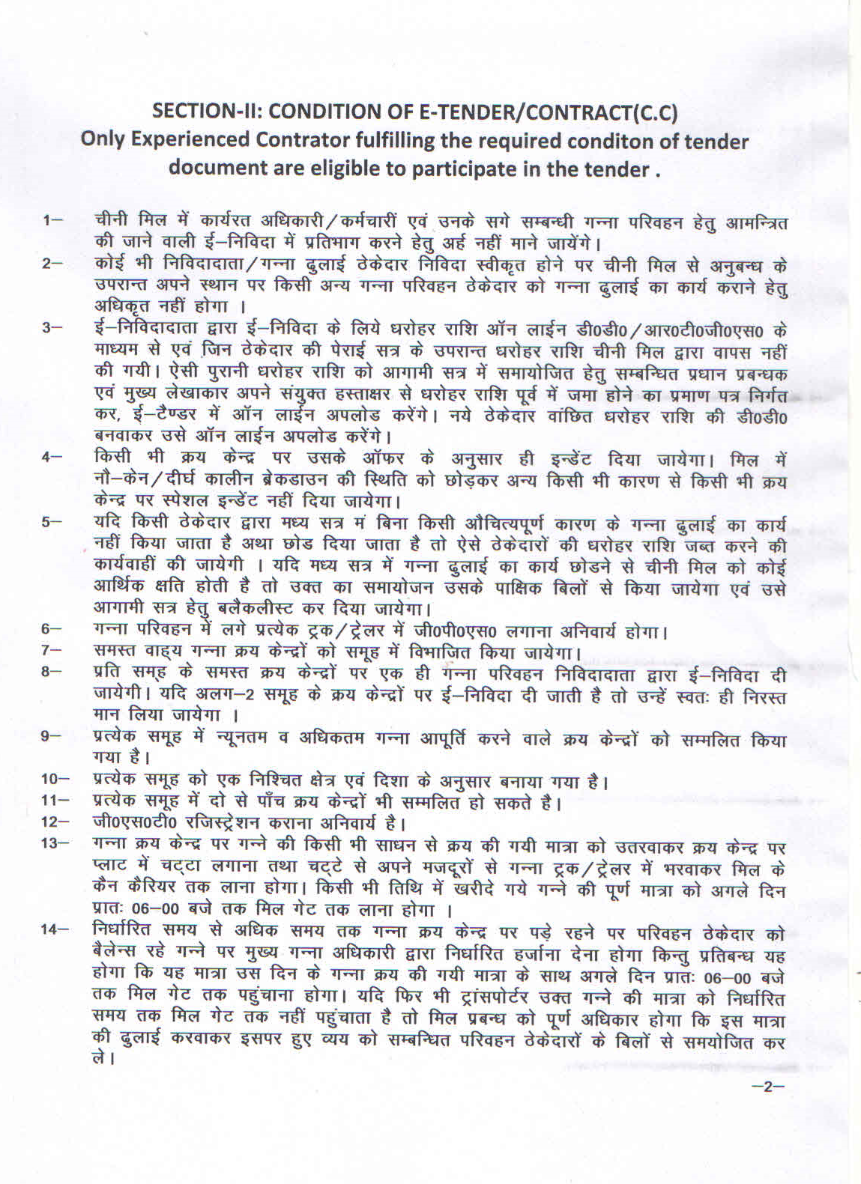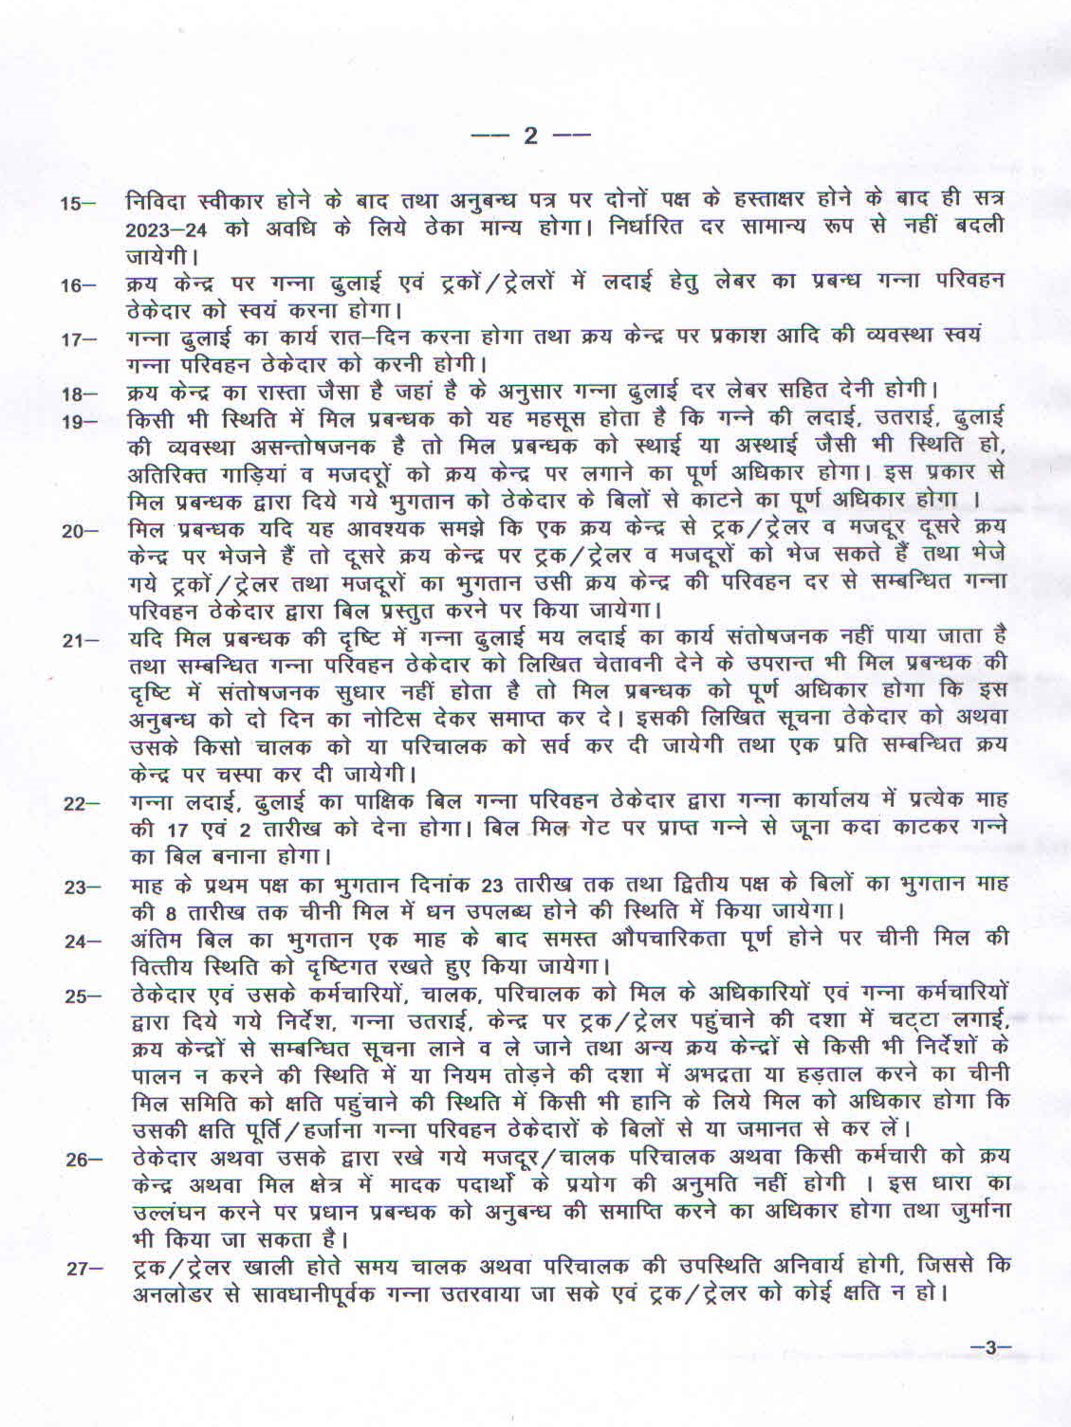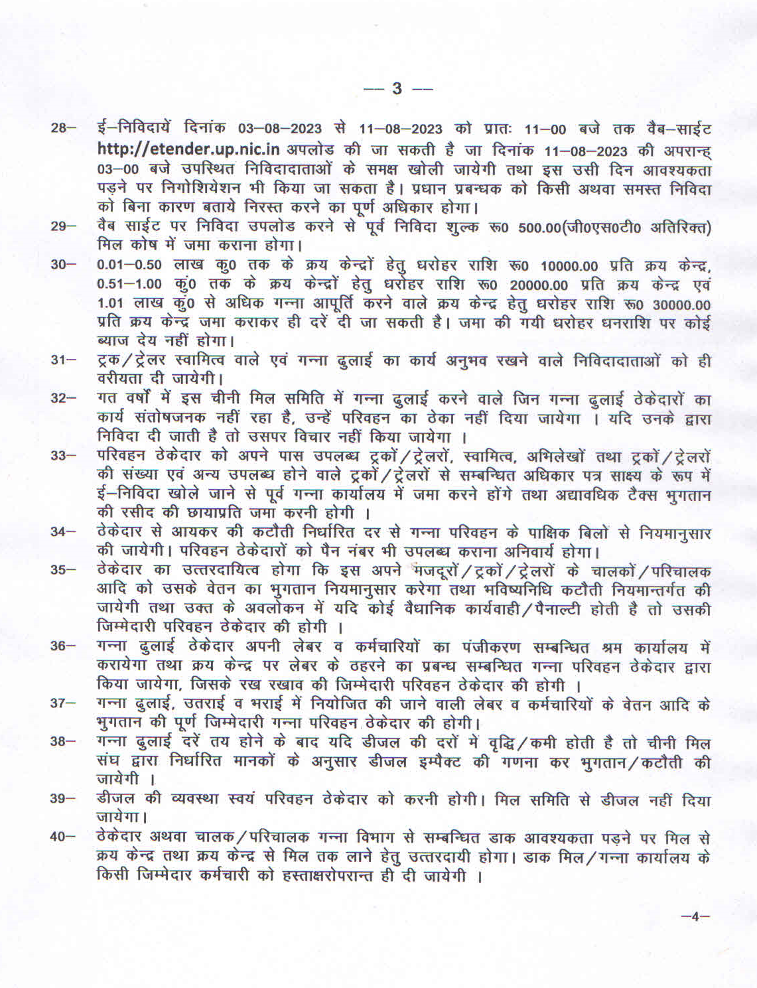

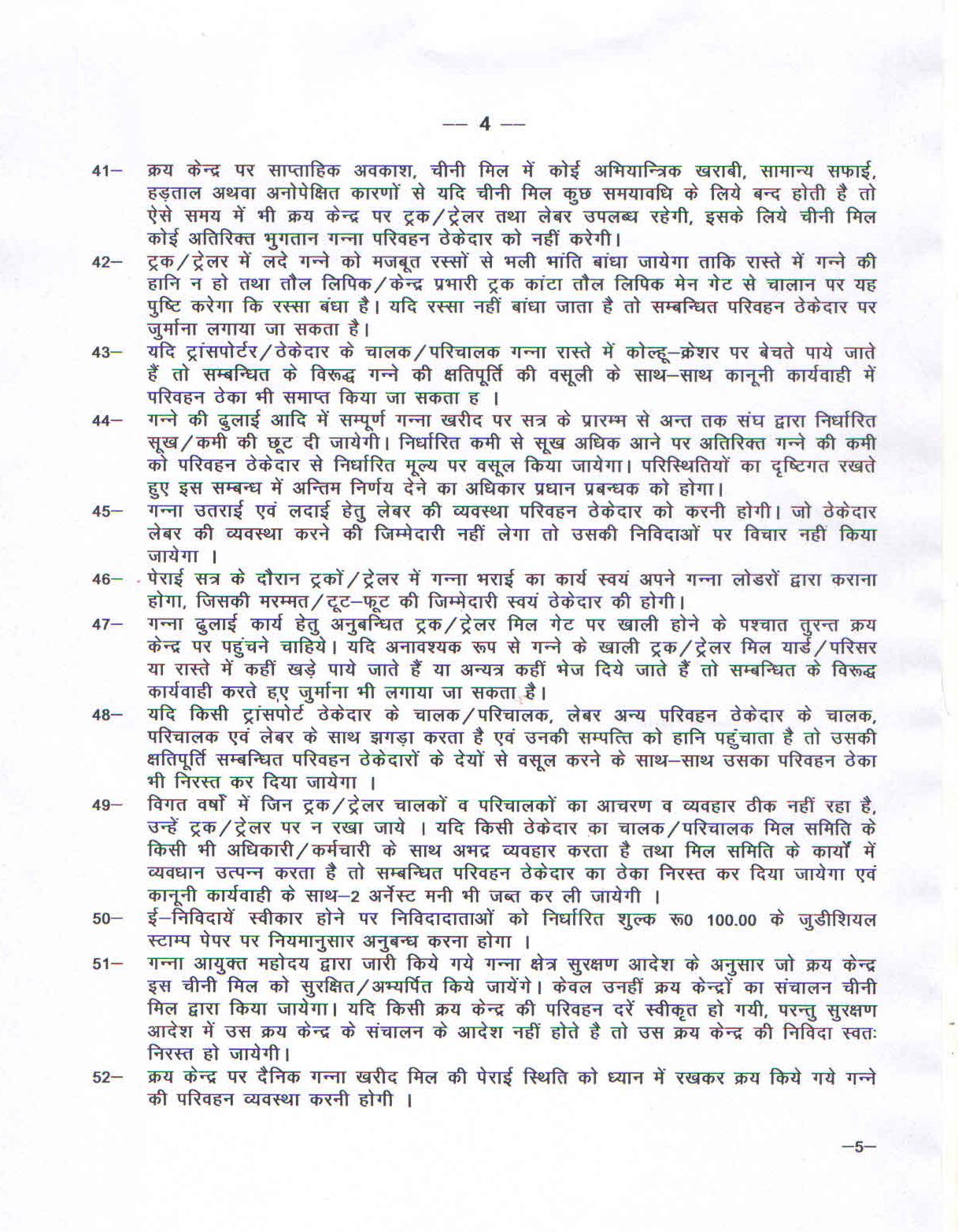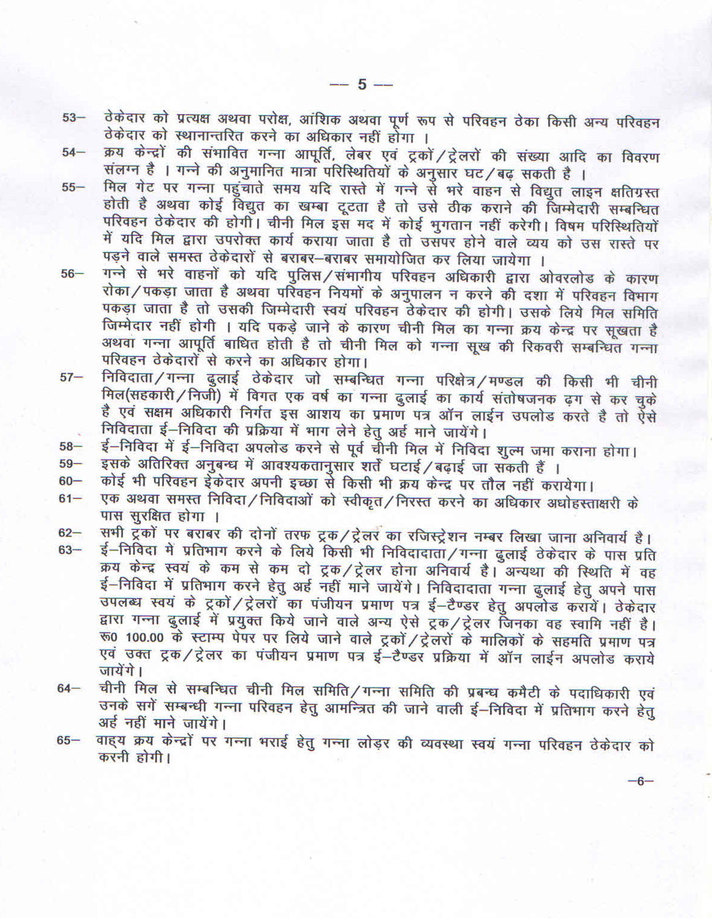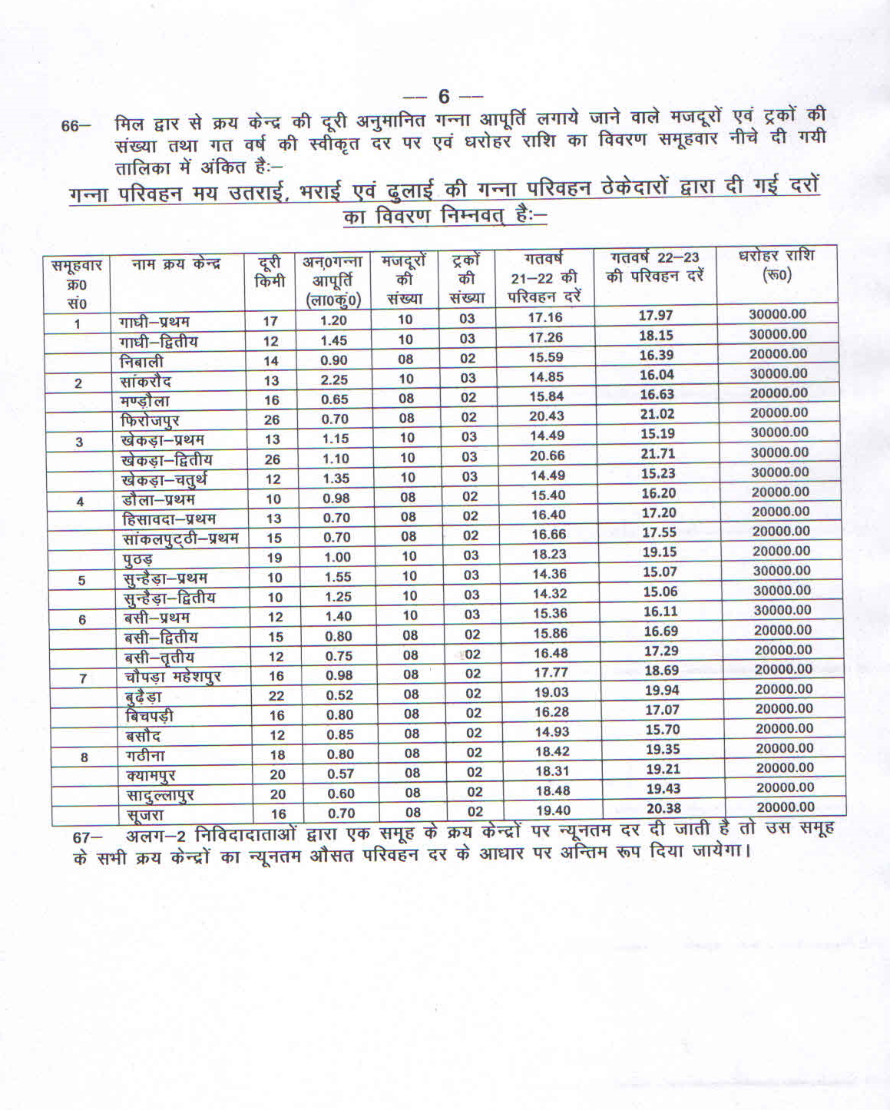

SECTION III: TECHNICAL E-BID

III(A) e Bid FORM

III(B) SCHEDULE OF REQUIREMENTS

III(C) TECHNICAL SPECIFICATIONS
III(D) CONTRACT FORM

III(E) PERFORMANCE STATEMENT

III(F) CAPABILITY STATEMENT

III(G) PERFORMANCE SECURITY FORM

SECTION III(A): e- bid FORM
Date:……………………….
IFB No CANE/C.T.A/2023-24/1015

The General Manager,
The BaghpatCoop.Sugar Mills Ltd.,
Baghpat

Dear Sir,
Having examined the e-Bid Documents, we, the undersigned,offer to deliver…………………………

( Description of Goods and Services) in conformity with the said e-Bid( Section II) of the e-Bid Document and will supply of Cane Transportation Workfrom our manufacturing works/units as per specifications ( Section III(c)) to your factories in addition to this, the particulars of our organiszation such as legal status, details of experience and past performance, capability statement and the required e-Bid EMD,E.M.D for 0 to 0.50 lac Qtl 10,000/- (Rs. Ten Thousand only), 0.51 lac qtl to 1.00 Lac Quintal Cane Supply Rs. 20,000/- (Rs. Twenty thousand only) for each Cane Purchase Center & E.M.D for Above 1.00 Lac Quintal Cane Supply Rs. 30,000/- (Rs. Thirty thousand only)for each Cane Purchase Center.
in the form of Demand Draft in favour of The Baghpat Cooperative Sugar Mills Ltd, is furnished with this e-Bid form.
We further undertake, if our e-Bid is accepted, to deliver theCane Transportation Workin accordance with the delivery schedule specified in the Schedule of Requirements (Section III (B)).

We agree to abide by this e-Bid for the e-Bid validity period specified in Clause 13.1 of the ITB and it shall remain binding upon us and may be accepted at any time before the expiration of that period.
Until a formal contract is prepared and executed, this e-Bid, together with your written acceptance thereof and your notification of award shall constitute a binding contract between us. All the terms and conditions of the e-tender Document are acceptable to us.
We undertake that, in competing for (and, if the award is made to us, in executing) the above contract, we will strictly observe the laws against fraud and corruption in force in India namely “Prevention of Corruption Act 1998”.
We understand that you are not bound to accept the lowest or any e-Bid you may receive.
Dated this……………………day of ………………..20…………..
----------------------------- --------------------
Signature (in the capacity of)

Duly authorized to sign e-Bid for and on behalf of ……………………………..

SECTION III(B): SCHEDULE OF REQUIREMENTS

Item Code | Brief Description | Destination | Delivery Schedule | e-Bid E.M.D
As per the details given in the  SECTION III (C)  TECHNICAL  SPECIFICATIONS |  | The Baghpat Cooperative Sugar Mills Limited, Baghpat | . To be dispatched as per requirement from receipt of order . Time to time. | E.M.D for 0 to 0.50 lac Qtl 10,000/- (Rs. Ten Thousand only), 0.51 lac qtl to 1.00 Lac Quintal Cane Supply Rs. 20,000/- (Rs. Twenty thousand only) for each Cane Purchase Center & E.M.D for Above 1.00 Lac Quintal Cane Supply Rs. 30,000/- (Rs. Thirty thousand only)

SECTION III (C) TECHNICAL SPECIFICATIONS

- Specifications

Cane Transportation Work specifications as per Tender Form

SECTION III(D) AGREEMENT

ACCEPTANCE OF ORDER WILL BE TREATED AS AGREEMENT EXECUTED

SECTION III(E) : PERFORMANCE STATEMENT
Cane Transportation work satisfactorily in previous Three year to sugar mills RFC or any public sector undertaking
Name of Company/Firm …………………………………………………

Order placed by (Full address of Mill Society) | Order No. & Date | Description & Quantity of ordered goods | Value of order | Date of completion of delivery |  | Remarks indicating reasons for late delivery, if any
 |  |  |  | As per contract | Actual
1 | 2 | 3 | 4 | 5 | 6 | 7

Signature and seal of the E-Bidder
With name of the authorized person

CHECK LIST

Sl No | Clause | Instrument/ Documents required | Page No
 | Clause 4 (Invitation for e-Bids) | Cost of e-Bid Document in Physical Form
 | -do- | Scanned Copy of Cost of e-Bid Document
 | Clause 5 (Invitation for e-Bids) | e-Bid EMD in Physical Form
 | ITB Clause  21.1  &  21.6 | Proof for Experience of Cane Transportation Worksatisfactorily in last three year to sugar mills of Govt. and private sector
 | ITB Clause  21.3 | Copy of detail of FEE and EMD
 | ITB Clause  21.4 | Copy of Authorisation letter by the competent authority for the authorized person.
 | ITB Clause  21.5 | copies of the registration certificate of industries department of the state
 | ITB Clause  21.7 | detail of last three years turnover duly certified by Chartered Accountant.
 | ITB Clause  21.8 | Copies of details of last submitted Income Tax Return/PAN card (self attested).
 | ITB Clause  21.9 | details of Trade tax/ CST Registration/ TINNO and Central Excise Registration Certificate
 | ITB Clause  21.10 | documentary proof of the Status of the company along with names of Directors/Partners/Proprietor along with documents
 | ITB Clause  21.11 | submit sample of the product to be given by the party along with technical bid ( if feasible) duly stamped and signed by the e-bidder.

 | SECTION  II | Acceptance to the Conditions of Contract
 | SECTION III(A) | e- bid Form
 | SECTION III(B) | Schedule of Requirements
 | SECTION III (C) | Technical Specifications
 | SECTION III D | Agreement/Order Acceptance
 | SECTION III (E) | Performance Statement
 | SECTION III (F) | CAPABILITY STATEMENT
 | SECTION IV (A) | e-Bid Form
 | SECTION IV (B) | BOQ

SECTION IV: FINANCIAL e-Bid

IV (A) e –Bid FORM

IV (B) PRICE SCHEDULE/BOQ

SECTION IV(A) : e bid FORM

Date

IFB No.CANE/C.T.A/2023-24/1015

To: ( Name and address of Mill Society)
General Manager,
The Baghpat Cooperative Sugar Mills Ltd.,
BAGHPAT

Dear Sir,

Having examined the e-Bid Documents, we the undersigned, offer to supply………….( Description of Goods and services) inconformity with the said e-Bid Documents for the rates as may be ascertained in accordance with the schedule of rates attached herewith and made part of this e-bid, and hereby undertake that we accept all terms and conditions of E-Tender/contract (section II) of the e-Bid Document and will supply of Cane Transportation Workfrom our manufacturing works/unit as per the Technical specifications( Section III (c) to your sugar factories. In addition to this, the particulars of our organization such as legal status principal place of business, details of experience and past performance ,capability statement and the required e-Bid security in the form of Demand Draft in favour of The Baghpat Cooperative Sugar Mills Ltd. Baghpat are furnished with this e-Bid form

We further undertake, if our e-Bid is accepted, to deliver the goods in accordance with the delivery schedule specified in the schedule of Requirements( section III(b))

We agree to abide by this e-Bid for the e-Bid validity period specified in Clause 13.1 of the ITB and it shall remain binding upon us and may be accepted at any time before the expiration of that period.
Until a formal contract is prepared and executed, this e-Bid, together with you ,written acceptance thereof and your notification of award shall constitute a binding contract between us.

We undertake that, in competing for (and, if the award is made to us, in executing) the above contract, we will strictly observe the laws against fraud and corruption in force in India namely “ Prevention of Corruption Act 1998”.

We understand that you are not bound to accept the lowest or any e-Bid you may receive.

Dated …………………………….day of ……………..20

……………………………….. ……………………..
(Signature & Name of official) ( In the capacity of )

Duly authorized to sign e-Bid for and on behalf of

SECTION IV(B): PRICE SCHEDULE / BOQ

